**u|Lg ;f];fO6L klAns :s'n**

**D-20**

**/Tggu/–&, ;f}/fxf lrtjg**

**klxnf] q}dfl;s** परीक्षा**—@)*@**

**sIff M–** g;{/L **समय -** @ **3+=** **k"0f{fÍM– %)**  **ljifoM–** g]kfnL -lnlvt_ **pQL0f{fÍM–!\***

|  |
| --- |
| **gfd : ====================================================/f]n g+=============;]S;g M ================** |
| **_________________________ ______________________ s'n k|fKtf**Í **:**  **lg/LIfssf] ;xL k/LIfssf] ;xL** |

!_ p:t} cIf/;Fu hf]8f ldnfpg'xf]; . -%_

s v

v s

3 u

ª 3

u ª

@_ ‘s’ cIf/df uf]nf] -○_ 3]/f nufpg'xf];\ . -!)_

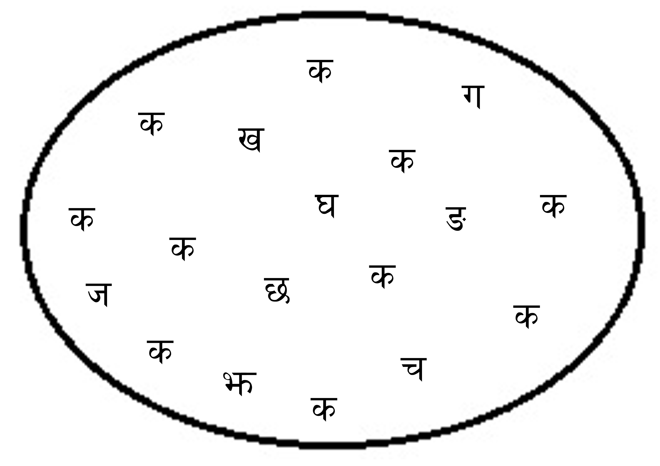

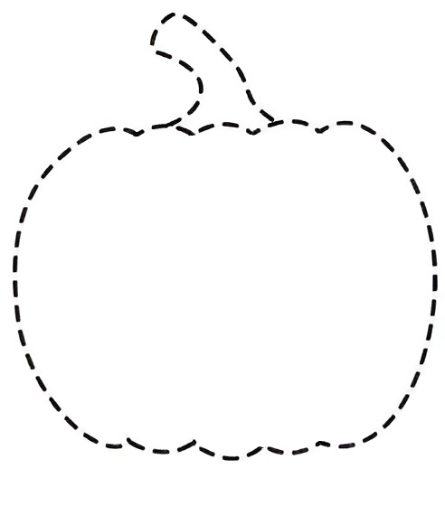#_ yf]Knf yf]Knf hf]8]/ lrq agfpg'xf];\ . -#_

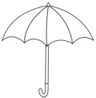$_ lrq / cIf/sf lardf hf]8f ldnfpg'xf];\ . -&_

s

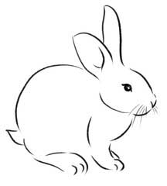u

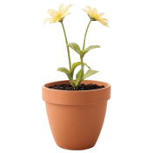r

3

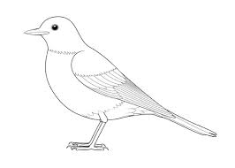 ª

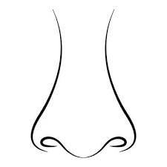 5

v

%_ p:t} cIf/nfO{ ;fg'{xf];\ . -!)_

s M __________ __________

v M __________ __________

u M __________ __________

3 M __________ __________

ª M __________ __________

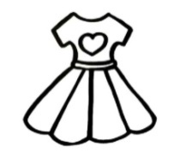^_ cIf/;Fu ldNg] lrqdf /ª eg'xf];\ . -!)_

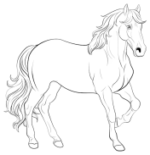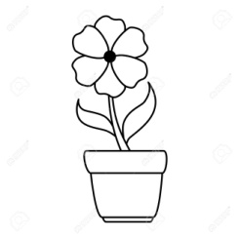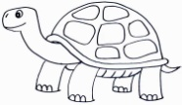s M

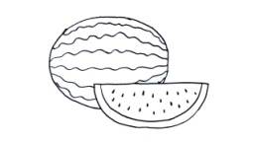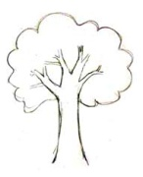u M

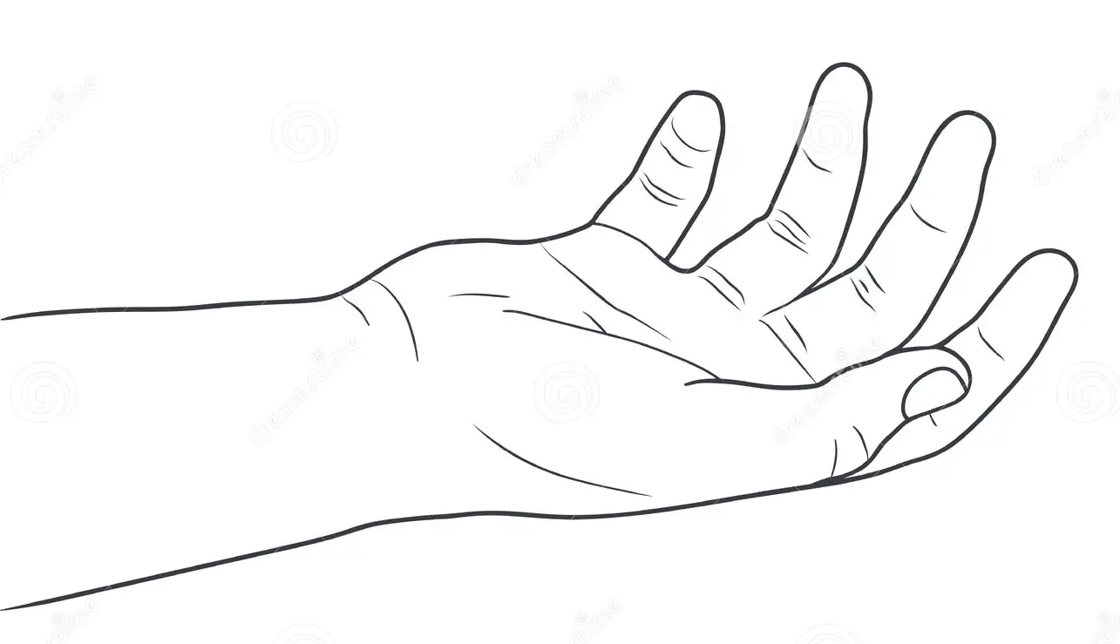

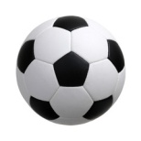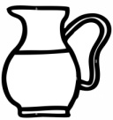v M

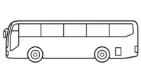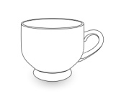5 M 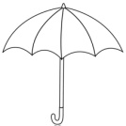

r M

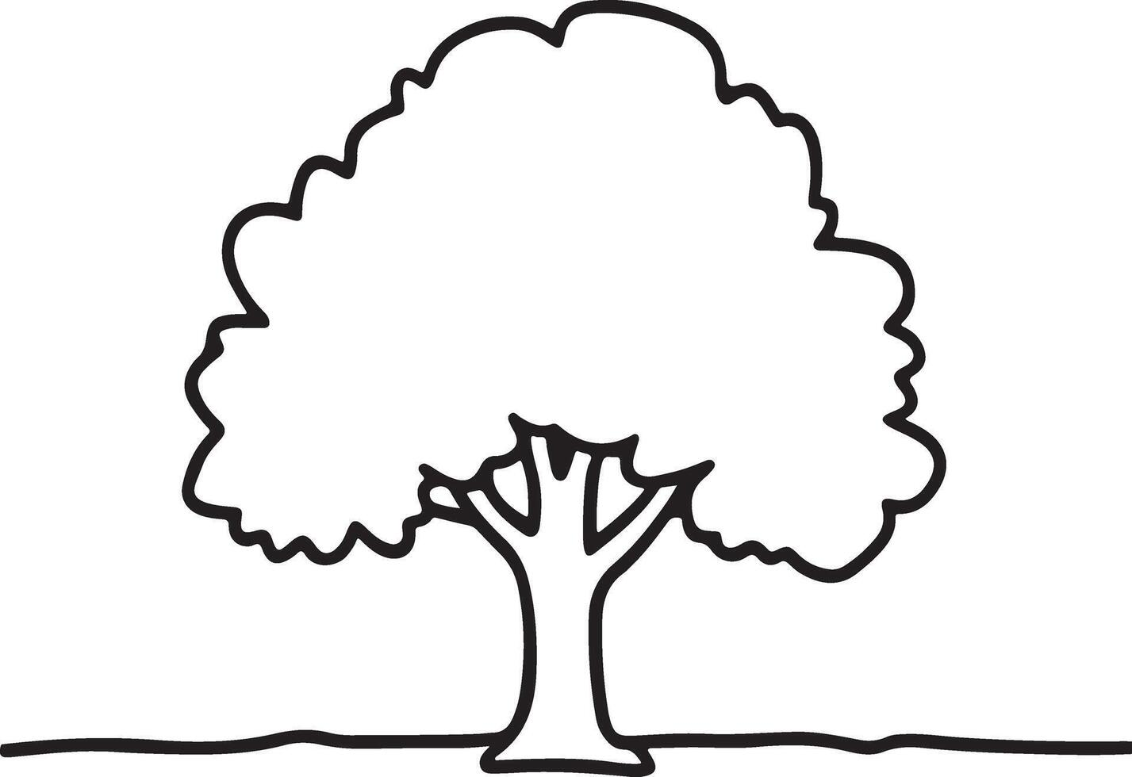&_ tnsf] lrqdf /ª eg'{xf];\ . -%_

;dfKt